Fundamentals 2
In this value-packed stage, you'll learn a whole suite of methods that take most people their entire lifetime to learn. Each technique is high-yield and forms a core part of any complete learning system.
Overview and recommendations
Key dimensions | Deep processing, self-regulation, self-management, retrieval
Recommended pace | Most learners see best results with around 5 hours of theory across 2 to 3 weeks, interspersed with practice throughout.
Recommended practice | Most learners see best results with a combined 4 weeks of practice, while learning new theory intermittently.
Progression notes | This stage has a wide spread of new techniques. Take each lesson and its associated recommended tasks one at a time. Avoid accumulating more than 2 focus tasks during this stage to prevent overwhelm. Most learners find the "In-class learning" and "Note-taking" lessons most time-consuming. However, these lessons are also the most important for building deep processing and self-regulation habits.
How this stage helps you
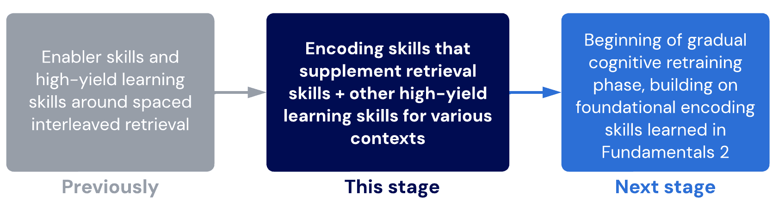

Important note
Fundamentals 2 is designed to help you create significant improvements in a very short period of time. If you are in a rush, have exams coming up, or want to improve your learning as quickly as possible, aim to master the techniques in Fundamentals 2 as the highest priority. Mastery of these techniques is usually sufficient for top-level achievement in most curriculums.
From the next stage, skill development will slow as we gradually upgrade our mental operating system (i.e. undergo cognitive retraining), helping us reach even greater levels of performance and efficiency.
Lessons
- Exam technique

This lesson covers the most important principles of performing consistently well during exams.
- In-class technique

Classes, lectures, meetings, workshops... learn to learn when someone is speaking to you!
- Note-taking
Good note-taking helps your brain think. Let's cover what "good" note-taking looks like.
Sub-lessons
- Notes and processing
- Study scheduling
Scheduling your study sessions is a simple and effective strategy many learners struggle to optimise.
- Revision
Interleaved retrieval can take a long time to master. Let's learn some high-yield methods to get you started.
- Rote-learning
Unfortunately, rote-learning and memorisation through repetition are necessary for many learners. Here's how to do it right.
- Fundamentals checkpoint
Let's bring everything together and ensure you've got a firm foundation before moving into the Growth phase.
Sub-lessons
- Demonstration of core techniques
- Exam technique
Exam execution guidelines
Follow these guidelines to ensure consistent performance during assessments.
- Get good sleep (especially before exams). Sleep is essential for exam execution due to sleep-dependent memory consolidation. The recommended amount is at least 9 hours in bed, per night!
- Use priority-checking to double-check answers you are unsure about while maintaining an optimum pace for other questions.
- Think like an examiner to evaluate your knowledge and consider how you can use it to solve challenging problems, especially in ways you are not confident about. View the interleaving table for methods.
- Use slow, deep breathing to activate the parasympathetic response, mitigate anxiety spirals and eventually train yourself out from anxiety pathways that may have become a habit.
Create a task!
Not every lesson has recommended tasks. This is because everyone has different things to work on. If this lesson is relevant for you, make some tasks of your own. You can do this by clicking Add a task and selecting custom task from the focus list on your dashboard!
Common questions
I only get nervous in high-pressure exams. What should I do?
If you’re already doing most of these things, you can use graduated exposure therapy. This is when you put yourself in increasingly similar scenarios to what triggers your nervousness. For exams, that means practising answering questions in more pressured settings before your actual exam. This can be done by adding strict time pressures, using exam conditions, and involving friends to increase competition.

I'm too busy and stressed before exams to remember these tips. What should I do?
Make a pre-exam checklist and mark on your schedule when to start going through the checklist. This could be weeks before your exam. We all forget things when we're under pressure. The trick is to use the methods of self-management we have learned so you create safety nets for your brain.

- In-class technique
In-class guidelines
Maximise learning and reduce overwhelm from classes, lectures and workshops by following these guidelines.
- Always prestudy. Prestudy improves your retention, engagement and enjoyment in class.
- Focus your prestudy on the big-picture concepts, not details.
- Always paraphrase and process information before writing notes.
- Don't avoid feeling challenged. Good learning feels uncomfortable because your brain is actively working.
- Write non-linear notes. Mindmaps and spatial representations are much more effective than linear notes.
- Limit your word-count. The more you write, the less you're processing. Learning happens in the brain.
Additional learning
Check out our article on how to prestudy for more guidance on this critical skill.
Alert: This is a high-yield lesson
In our experience, learners see dramatic improvements in learning quality and overall learning experience by applying the techniques from this lesson. Likewise, we commonly find significant issues for learners who do not practise or apply the methods from this lesson sufficiently.
Common questions
I don't have time to do any prestudy. What should I do?
Prestudy is more valuable than reviewing previous material. This is because effective prestudy reduces how much you forget and prevents you from becoming continually overwhelmed.
If the bucket leaks, it's more important to plug the holes than to keep filling it.
How do I know if I am doing prestudy correctly?
Prestudying should help you feel:
- Less overwhelmed
- More able to consolidate and make sense of information from class or lectures
- Generally aware of the main ideas that will be covered
- Able to ask deeper or more interconnected questions (if asking questions is possible)
If you do not feel this, ensure your technique is correct by reading this guide.
I've never tried prestudying before. How long will it take to do it correctly?
With daily practice, learners can develop sufficient skill after around 1 to 2 weeks. However, this range is only approximate. Each person has their own pace, and you should focus on using your own perception of skill to guide your progress.
Read our article on how to know when to move on for more guidance.
I struggle to think and process before writing notes. What should I do?
This can indicate a weakness in deep processing. Don't worry. It will get easier with time! You can train this by delaying your note-taking for as long as possible (until you feel like you will forget). Over time, try to extend how long you can delay note-taking.
Tip: You will find it easier to delay note-taking when you constantly relate information to the big picture and try to simplify and group new information together.
- Note-taking
Note-taking guidelines
Follow these guidelines to make sure your note-taking helps your brain's ability to process information.
- Always manipulate knowledge in a different way to how you consumed it.
- Use non-verbal and non-linear note-taking to manipulate knowledge through visual and spatial parts of your brain.
- Improve your note-taking with baby steps.
- Limit your word-count. Look for big chunks of text in your notes that can be expressed through mindmaps, symbols, arrows, and doodles.
Tips for visualisations
While using imagery can be a powerful memory cue, there are some important considerations to ensure you receive the maximum benefit.
Avoid over-visualising
Over-visualisation refers to when learners turn too many words into visuals. Using the same "landmark" analogy, having too many images and visualisations reduces the benefit on our memory because there are too many landmarks. It's like having a different landmark at the end of every street! This can get overwhelming.
Images are best used to reduce big chunks of text or create memory anchors for core principles that are either conceptually important or at higher risk of forgetting.
Keyword anchoring your images
Images can help create memory anchors for knowledge. These act as mini cues within your notes to help trigger your ability to recall information. Think of them like "landmarks" in your notes.
To make it easier to review your notes in the future, add a keyword under each drawing to make sure you remember what the drawing stands for. This way, we get the benefits of creating "landmarks" while also ensuring we don't forget what the drawings represented in the first place!
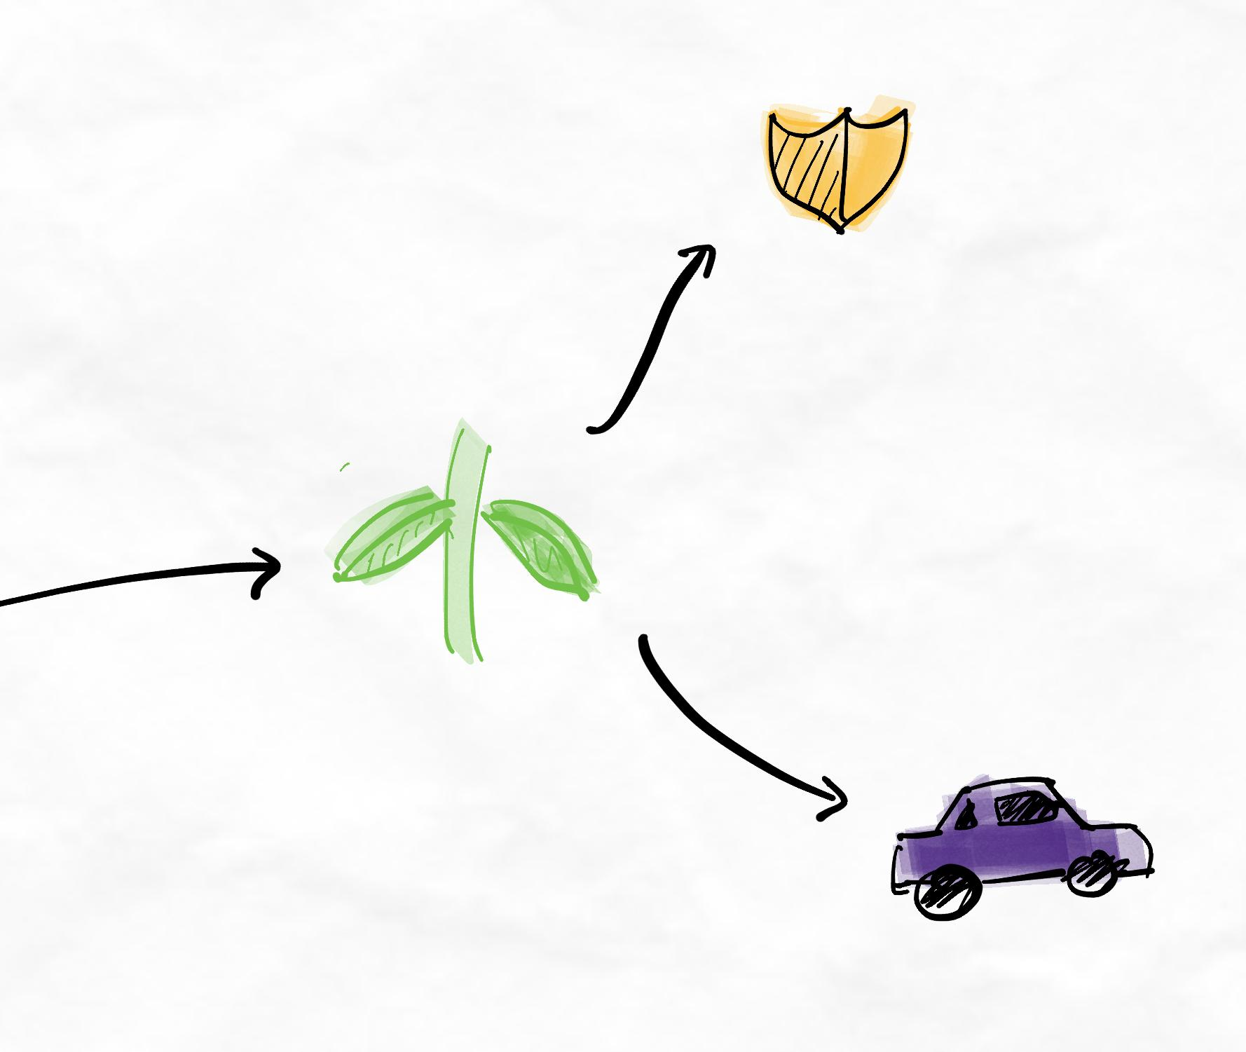No keyword anchoring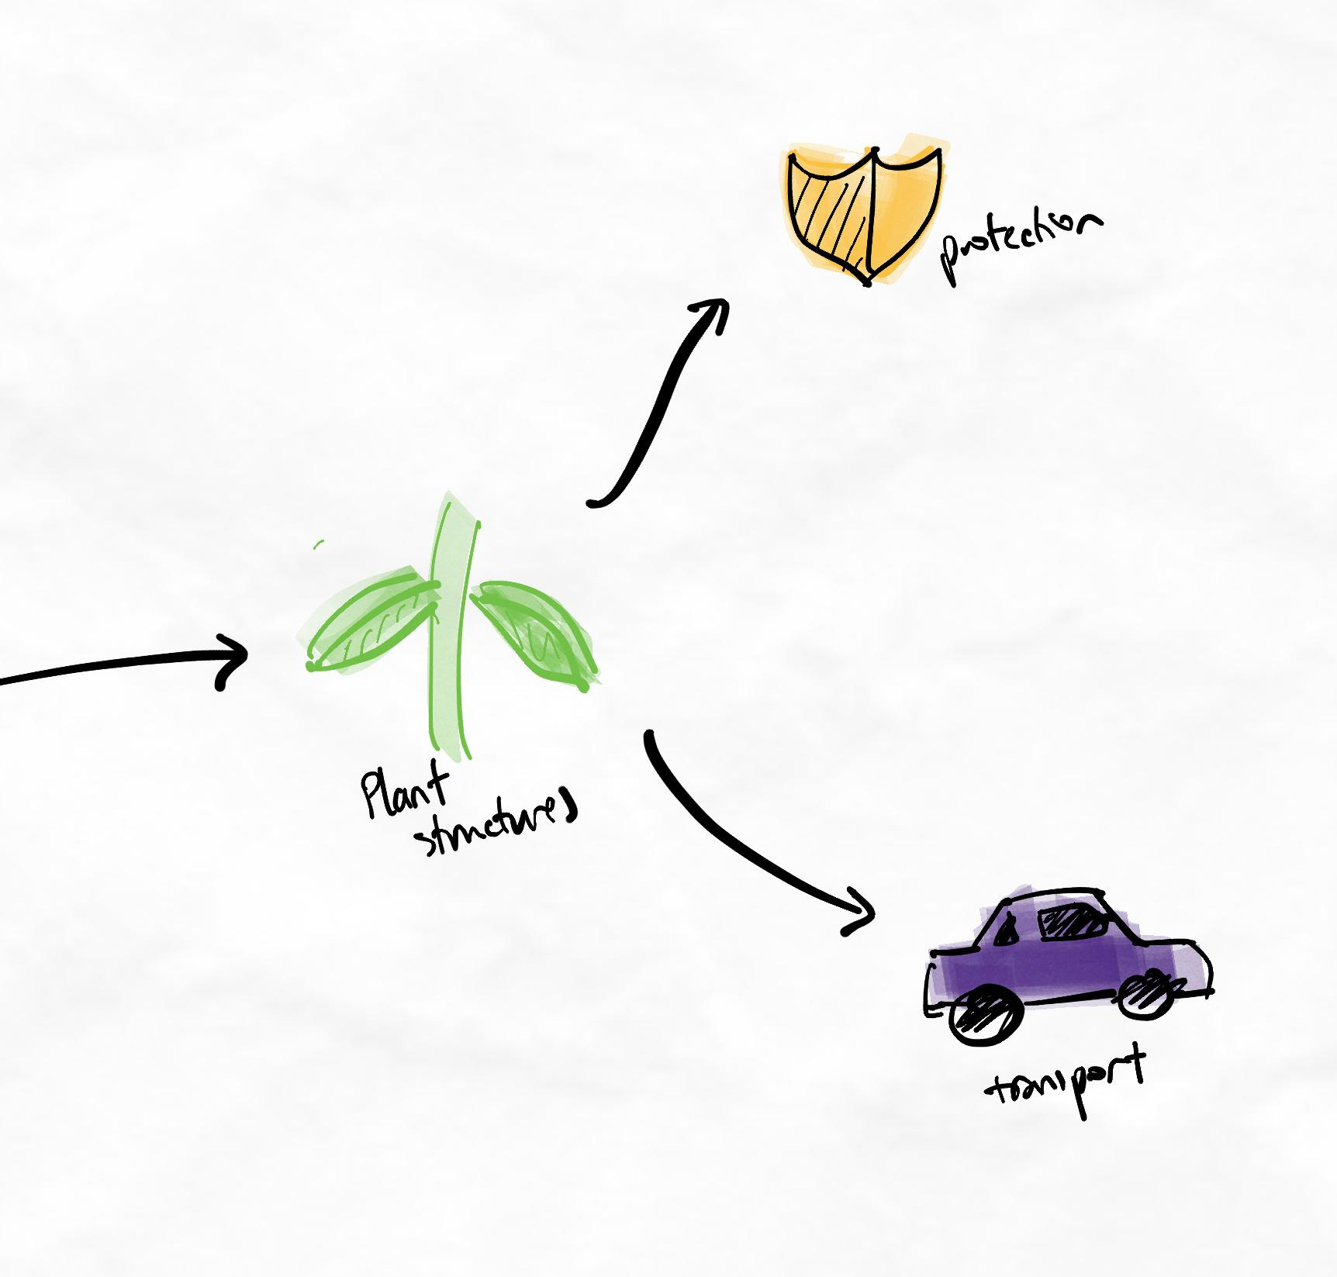Keyword anchoring added
Avoid hieroglyphics
Hieroglyphics refers to a method of visualising notes where the same images are used repeatedly instead of words. When this occurs, the imagery loses its memory benefit because it is too repetitive and common. Instead of being a "landmark", they become like streetlamps. Imagine trying to remember every streetlamp in a city!
In the following example, the following equations have been converted into images:
- Metal + acid = salt + hydrogen gas
- Metal + water = metal hydroxide + hydrogen gas
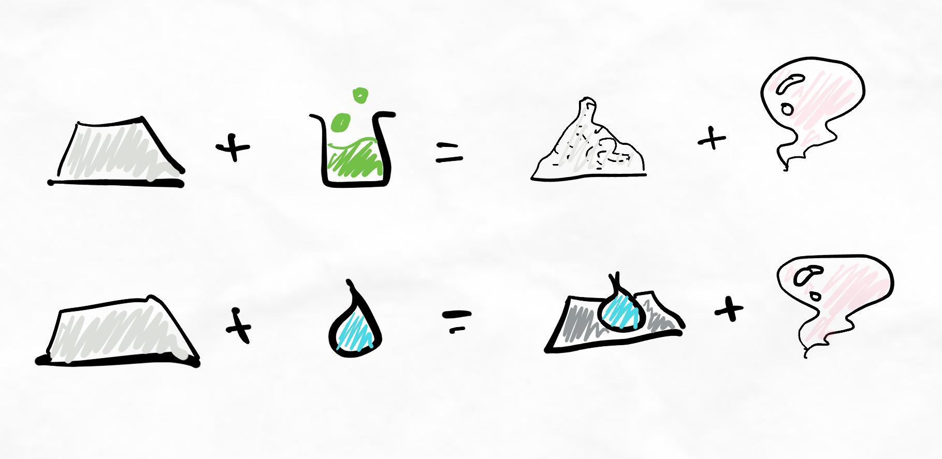Metal reactions represented with hieroglyphics.
As you can see, images are used to replace a word directly, and they are used repeatedly. Therefore, this would be considered "hieroglyphics" and is not any more memorable than using words.
Consider the next example:
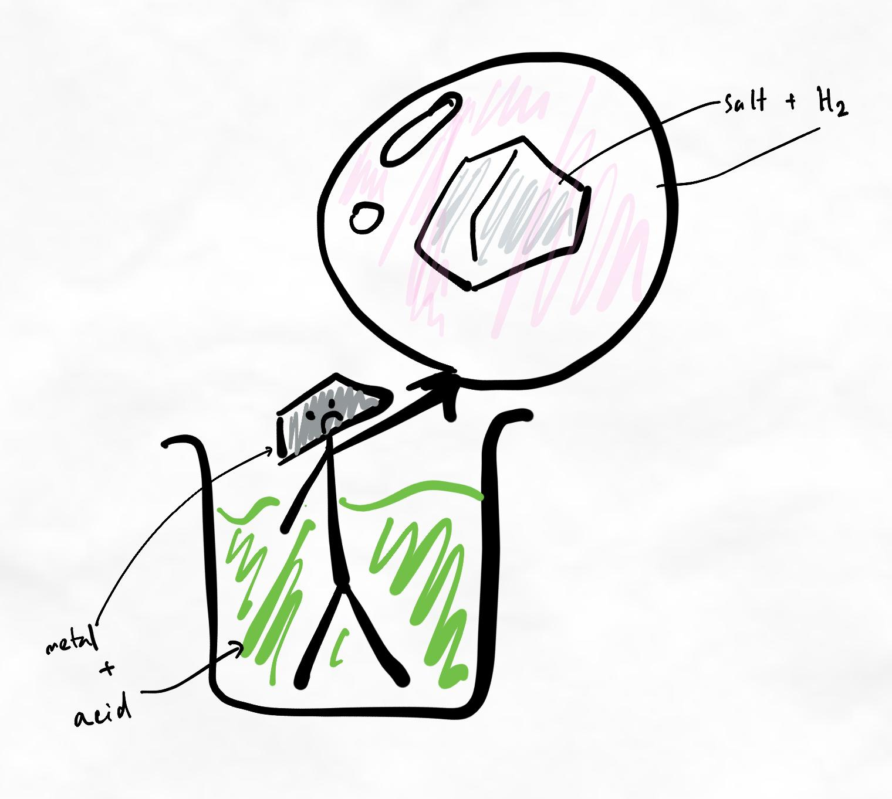A more "landmark"-like image, including keyword anchoring.
Here, we've used common elements of imagery to create a more memorable image for the reaction of "metal + acid = salt + hydrogen". The additional processing and thought required to think of a more "creative" image also improves memory and retention.
Draw it yourself
While taking screenshots and diagrams others have made can be tempting, do so sparingly. A significant portion of the advantage of creating visualisations comes from the processing and thought required to think of imagery that is appropriate and memorable. By avoiding this work, we also avoid the beneficial effect it has on encoding.
Furthermore, diagrams and images from more "technical" sources are often too dense and detailed to be memorable.
Images are just memory cues
In the next sublesson about Notes and processing, we will introduce other methods of thinking and note-taking involving creating groups and relationships. Creating groups and relationships is superior to simply creating an image.
In the above example, with a chemical reaction, this information is better learned through good logic and a deeply processed understanding of the concepts. Relying on a superficial memory cue like this image is less efficient. The example with chemistry was used in this lesson as it is a common example where learners often use hieroglyphics.
Visualisations and memory cues can help to reinforce the information if it has been processed and grouped already.
Common questions
I can't draw very well. What should I do?
Check out our article on how to draw to learn! It's much easier than you think. After all, we're drawing to learn, not sell our doodles to an art gallery.
I'm not used to writing notes this way. What should I do?
If this is mostly new to you, we recommend you take it slow. Correct note-taking is an important part of studying. It's also a bottleneck for many students because linear note-taking is extremely limited.
You may want to gradually change how you write your notes over the next 2 to 3 weeks. You can also practise other techniques in the meantime – especially the in-class techniques, which overlap heavily.
Over time, it will become easier and more natural for you to write non-linear notes!
Sublesson: Notes and processing
About this strategy
Collecting and processing is a transitionary technique, meaning we use it to transition between different strategies. In this case, we use collecting and processing to transition from heavily linear notes to processed notes. It helps learners spend more time thinking and analysing the information to break the habit of passive, mindless note-taking.
If you already feel comfortable with non-linear note-taking (e.g. mindmaps), you do not need to use this transitionary technique.
Technique overview
Many people don’t learn new information properly. They write it down in their notes and assume they have learned it. But why don’t you absorb some information even after writing pages of notes? And why can you learn other things (e.g. details about your favourite TV show) without writing any notes?
Clearly, our brain doesn’t learn information just because we wrote it down. This is where processing notes comes in.
Step 1: Collecting
While collecting, make the information as concise as possible. Only include keywords; remove words that are not needed, like “the” or “and”. You can use symbols like → or + to represent words or meanings. This step is very easy and does not activate any learning. It is simply a setting-up step for processing
Step 2: Processing
Processing involves thinking about the information to make sense of it and simplify it. Try to represent the information in the simplest way possible, bringing together as many concepts as possible.
Try moving from collecting to processing after every concept so that we are progressively building a more extensive network. As you continue to process, your "web" or "network" of knowledge should grow as more relationships, arrows, and groups form.
Don’t be afraid to oversimplify things! The details will always be on the left in the collection column. You want to focus on representing the main ideas as effectively as possible on the processing side.
Important note
Processing your notes is a core learning skill. Therefore, the note-taking skills and methods you learn in this step should carry over to all other note-taking you do later. In the future, when we teach you to create mindmaps (or more accurately, chunkmaps), we expect that they will still be processed.
Grouping and creating relationships
Grouping and creating relationships is one of the most important skills for improving your learning efficiency and deep processing.
The thought processes involved in forming groups and creating relationships are crucial for high-quality encoding. Ask yourself:
- How can I group this information?
- Does it still make sense?
- What does it relate to?
- Why is this important?
- How does it fit into the big picture?
Optimising our learning
The power of grouping comes from the activation of higher-order learning.
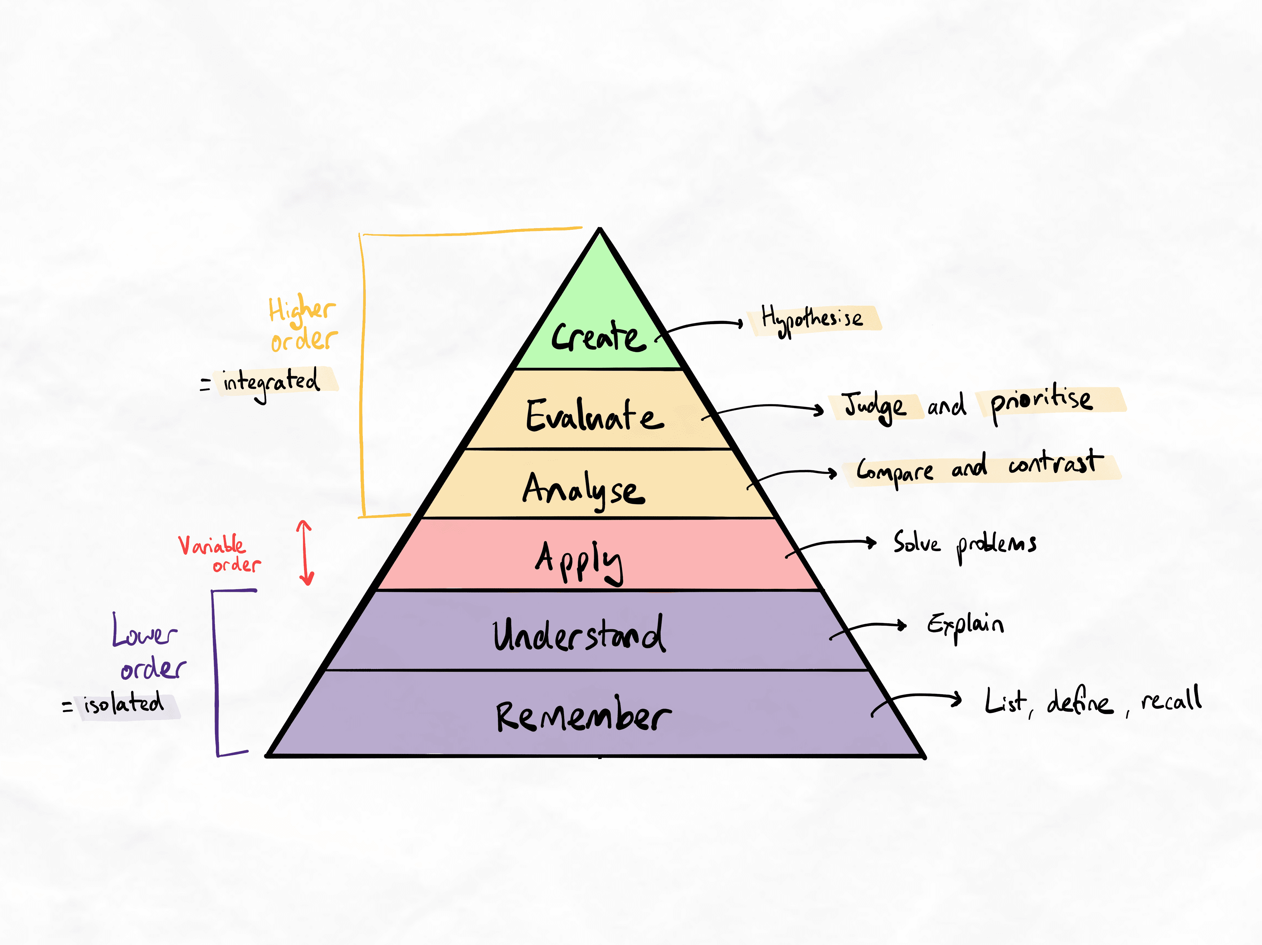Bloom's revised taxonomy showing higher-order vs. lower-order learning.
Whenever we form groups and relationships, we want to ensure we prioritise them. This involves making a value judgment on how important one group or relationship is compared to others.
Key principle
Making a value judgment on the importance and relevance of information is ultimately subjective. Try your best to make an accurate judgment by reading and learning about the topic.
The time and effort involved in making this judgment directly contributes to effective learning.
On Bloom's revised taxonomy, we are activating the evaluate level of learning. This creates significant improvements in depth and retention of knowledge and is one of the most crucial steps to efficient learning.
You often won’t be sure which concepts are the most important or which way of grouping makes the most sense. This is normal! When this happens, revisit the material to gain more information and clarity. This back-and-forth process (where we think, question ourselves, seek answers, and consolidate) is precisely what higher-order learning feels like!
It may differ greatly from how you usually learn if you have mostly lower-order habits.
Prioritising to a high level
To help you prioritise relationships or groups, ask yourself these questions.
- What are other ways that these concepts are similar to each other?
- What wider purpose do these concepts have?
- Why do I need to know this? Why is this relationship important?
- What is the simplest way I can group these ideas together while keeping the relationships accurate?
There is no right or wrong here. The key is switching to a problem-solving mindset. This makes it easier to retain information compared to memorisation through repetition.
This foundational skill of processing notes will help tremendously when transitioning to more advanced techniques later in the program.
A note on the Cornell note-taking method
You may notice that this technique shares similarities with the well-known Cornell Note-Taking Method. The Cornell method is also a beginner-level technique; however, it is more limited and does not transition to more efficient note-taking. The Cornell method reflects a more outdated approach to note-taking. It is superior to the typical linear methods that most learners still use but is less effective than the methods you will learn in this program.
4.Study scheduling
Study scheduling guidelines
Follow these scheduling guidelines to sustainably cover your core encoding and retrieval sessions needs.
- A simple guideline for revision spacing is 1 day, 1 week and 1 month. If you have a similar spacing schedule that you have learned from our previous lessons, feel free to continue using that.
- Schedule retrieval sessions in your calendar, and stick to that schedule.
- Prestudy material before class. This will save you time later by reducing the amount of revision you need to do.
- Schedule time for prestudy. Prioritise and protect this time, especially when you’re busy.
- Snowball your learning of the topic. Learn superficially but broadly during prestudy, and eventually add more in-depth knowledge every time you study it.
An easy schedule template
The following is a basic schedule that you can follow to start with. This schedule should be sufficient for most learners to get used to following the essential guidelines above.
For more advanced schedules for spaced interleaved retrieval, read our article on spacing and scheduling here.
Day and time | Activity | Focus while doing the activity
Sunday anytime | Prestudy the week’s material | Learn just the concepts and how they relate to each other. Don’t memorise any processes, steps or definitions. Make a very basic mindmap.
End of every weekday (after learning in class) | Revise the day’s material | Build a more detailed understanding of the topic. Create flashcards and elaborate on your mind map. Don’t spend time memorising definitions or highly detailed information yet. Focus on having a solid understanding of the concepts and how any processes work. Don’t make flashcards for conceptual information.
End of every week, e.g. Friday evening or Saturday | Revise the entire week’s material | Use an interleaved retrieval method for revision and return to any weaknesses and gaps. Start to memorise details. A good initial technique to use here is teaching and creating challenging questions.
During the week, at any available pocket of time | Go through flashcards. | Don’t worry about getting through all of them; just do whichever ones you can, given the available pockets of time.
End of the month on a weekend | Revise the entire month’s material. | This should be surprisingly easy as you have kept yourself from forgetting much. Use another interleaved retrieval method. By now, you should have memorised most of the details via the flashcards you have been consistently doing.
Two to three weeks before the test or exam | Do more retrieval practice. | Use another interleaved revision technique such as practice papers, challenge questions and peer quizzing. Brush up on any details you keep forgetting.
If you have a lot of content to cover, you can add another revision session in the middle of the month (as a fortnightly review) or the middle of the week (as a 2-day review).
You can adjust the exact days in the example schedule to suit your needs. For example, instead of “Sunday anytime”, you can do your prestudy on Saturday or Monday morning. You can do two weeks’ worth of prestudy at a time instead of one week’s worth. In later lessons, we will develop your ability to prestudy an entire topic (4–6 weeks’ worth) in one go.
Preview is better than review
Prestudying saves time on revision as you forget less. Therefore, as your prestudy technique improves, your revision time will decrease. Given the choice between doing good prestudy vs. reviewing previous material, always choose prestudy.
You can always catch up on reviewing material later, but prestudying helps you have less to catch up on in the first place.
Common questions
I'm struggling to follow these schedules. What should I do?
When we start to put more of these tasks in your schedule, it's common to identify weaknesses in your time and task management skills. In most cases, if you struggle to follow these schedules, it is because of:
- issues with basic time management skills, or
- issues with task prioritisation (such as prioritising retrieval sessions instead of good quality prestudy sessions)
Depending on where your issue is, this could be a cue for you to work on reviewing your self-management skills from the earlier modules. Just because this program starts with one lesson and moves in a linear order, don't let that stop you from going back and reviewing older lessons!
Great learners know when to go back and forward based on closely monitoring their knowledge gaps.
How long do I need to practise using these schedules to know I have competence?
Give yourself a couple of weeks to use this new kind of schedule. You can also work on other techniques simultaneously. Scheduling does not have a long learning curve, so most students can set a schedule and start using it relatively quickly.
However, it can take a little experimenting to make it suit your needs. Make sure you get real-life experience and reflect weekly on what isn’t working and how you can improve it.
5.Revision
Improving your retrieval skills
We've already looked at how you can enhance your learning system with spaced, interleaved retrieval. However, as you can see from how extensive the interleaving table is, it can take a long time to find the right combination of methods and master them.
Instead of halting your progress while you learn these, this lesson introduces some high-yield techniques that can work well for many learners across most disciplines and levels of learning.
Test, target, teach
Test
When you test yourself, remember...
- Apply your knowledge.
- Create your own questions and use premade questions.
- You can share these questions with your friends in a small study group.
Why use self-made and premade questions?
Creating your own challenge and exam questions can be more effective than using past papers and premade practice questions. Even if you don’t fully know the correct answer, you learn more from creating the question and attempting to answer it than you would from answering an existing question.
Use premade questions to:
- Save time
- Familiarise with the style of questioning in your actual assessments (but remember there's no guarantee and it could change)
- Find gaps in your knowledge by testing yourself in ways you wouldn't have thought of
Use self-made questions to:
- Strengthen your understanding of material you've already learned from a different angle
- Find knowledge gaps in content you've already learned
- Practise retrieval in all the ways (orders and types of knowledge) you need (it's easier to target weaknesses when you can control the type of retrieval challenge
Protect your performance
An over-reliance on premade questions is one reason curveball questions throw students off so much. Creating your own questions is especially useful in subjects like maths and physics, which can often trip up students with real-world applications of formulae and equations that students don’t usually think of.
Stay ahead by anticipating curveballs before they are thrown! Good learners always use a combination of self-made and premade questions.
Note that there are significant overlaps between this method and the advanced group study method taught in the interleaving table. If you feel confident with the advanced group study method, you can use that instead.
Target
When you target your retrieval practice, remember...
- Look for areas you feel less confident in or have not used before.
- Start with areas of weakness, even if it feels uncomfortable.
Teach
When you teach content, remember...
- Some methods of teaching are more effective than others.
- Don’t just “explain” – teach! Change the order and approach when presenting the information so it makes sense for someone who hasn’t learned it before.
Teaching challenge
An effective way to find your weaknesses is to explain why a concept is important before introducing any terminology. This means you need to find a way to explain it in lay terms. For example, imagine you are teaching the concept to a 10-year-old.
When you find knowledge gaps
Using these methods, you can find knowledge gaps. Knowledge gaps are:
- Any parts you struggle to recall
- Any parts you get incorrect
- Any parts you feel unconfident about
Knowledge gaps are not only when you get things incorrect!
Every time you find a knowledge gap, review your material and re-encode it using the other methods we have taught you. Whichever methods were used to learn it initially can be used again. However, try to connect the information more deeply or try to make sense of it from another perspective. This helps to improve your retention and depth.
Common questions
How much do I have to practise this before I know I have sufficient competence?
Try to do all three (test, target, and teach) at least once before moving on to the next set of lessons. You can continue to refine this skill over time, but the gaps in knowledge you find from using this technique will change how you interpret future learning. It will be beneficial to have this experience at least once or twice before moving on.
There are two signs that you should spend longer to practise before moving on:
- You struggle to apply these methods
- You find it very easy but do not find any knowledge gaps
If you struggle with these methods, it is worthwhile to spend a couple more weeks practising them to reap the benefits. This prevents overload and maximises your learning efficiency.
If you do not struggle but also do not find any knowledge gaps, it most likely indicates that the technique was performed incorrectly. Unless you truly have pristine knowledge, you should be able to find gaps. Retrieval techniques are meant to find gaps. Not finding any means it was ineffective.
If the technique was easy and ineffective, it may indicate that they did not cover all the necessary orders of learning or types of knowledge testing. In this case, read our article on measuring your learning efficiency to see if you are testing the appropriate levels.
- Rote-learning
Rote learning guidelines
To do rote-learning and memorisation more efficiently, follow these guidelines.
- Basic association allows you to make items more memorable by assigning highly memorable imagery to them. We can draw this imagery in flashcards or our notes.
- Our brain is not good at memorising using words alone. Use visualisations and imagery too.
- Make sure you use active recall instead of recognition.
- Recall is more effective when combined with good spacing and interleaving.
- To memorise details you might forget, use digital flashcards for spaced repetition via the Leitner system.
- Try not to do flashcards in batches. Instead, do them throughout the day via microlearning.
Remember
Rote-learning is only necessary for around 30% of university material or around 10 to 20% of high school material.

Common questions
How long do I need to practise these techniques before moving on?
Rote-memorisation techniques are often easy to master with very little practice. Try to use some of these methods in your learning for one or two study sessions. There is no need to delay moving on. It is more likely that you will need time to coordinate how these rote-memorisation techniques balance with your encoding and interleaved retrieval methods. This coordination can be worked on over time.
- Fundamentals checkpoint
Checkpoint items
To move on, you must have around 80% competence with the skills taught so far. Use the list below to check whether you're ready!
Note: Lower levels of competence with even one of the items can be problematic during later stages where we build on these foundations.
Fundamentals checkpoint
- You have experimented with changing your methods and have learned from mistakes.
- You are finding it easier to notice and track your skill progress in relation to marginal gains.
- You have experience with managing discomfort and confusion while learning.
- You are using multiple techniques simultaneously in a system.
- You are finding it easier to prevent your notes from being too wordy by using keywords and avoiding full sentences, paragraphs, and lists.
- You are finding it easier to use non-linear notes and represents relationships between ideas.
- You are able to organise similar information into groups and categories based on how they are related to each other.
- You have implemented a basic spacing schedule.
- You have used interleaving methods that are appropriate for your knowledge type and required order of learning.
In the sublesson, you will see a demonstration of the level of skill we expect by the end of the High-Yield Phase. Please complete the recommended task below before viewing the sublesson.

Recommended tasks
Add tasks to your focus list so you can practice the skills.
Dimensions
Fundamentals 2
Practise your core High-Yield encoding techniques
Practise your core fundamental encoding techniques, including:
  - Non-linear note-taking
  - Delayed note-taking
  - Grouping and categorising
If you do not have any material to practise on, please use our interactive curriculum as a resource. You can also use Wikipedia articles in combination with YouTube videos on the same topic to create your own custom "curriculum". Perhaps there's something you've always wanted to learn about but never had the opportunity. Now's your chance!
You can then compare your attempts with the demonstration in our Fundamentals checkpoint lesson to assess your skill level.

Table of contents
Sublesson: Demonstration of core techniques
Demonstration of core techniques
Before you watch
The following demonstration uses our interactive curriculum module as practice content. We strongly recommend that you attempt this yourself before reviewing the demonstration to make an accurate judgment of your true skill level.
You can access the interactive curriculum module from the Supplementary Learning page in your Toolkit.
This video has been intentionally edited to show the thinking time and thought processes involved in studying the topic.
Congratulations!
You've reached the end of the High-Yield Phase. The Growth Phase is unlocked 14 days after you completed Rapid Start. Based on our recommended rate of progression, it should already be unlocked for you now!
If Growth Phase is still locked for you...
If you were moving through the lessons faster than this and the Growth Phase is still locked, please use this time to practise and deepen your mastery of the High-Yield phase. Over 90% of the problems our learners face in the Growth Phase come from inadequate practice during the High-Yield phase!

End of Fundamentals 2 quiz
Spot the issues!
In the following quiz, we will show you some work submitted by real students. Each case has a common mistake for you to learn from. Sometimes, you will learn about certain mistakes for the first time from these checkpoint quizzes!
The impossible quiz
This quiz is designed for you to fail on your first attempt. This is because you will intentionally be tested on concepts that have never been explicitly taught to you.
Impossible quiz instructions
How to make the most out of these quizzes
- On your first attempt, try your best to get the questions correct by using logic and thinking about the principles you have learned. It is 'technically' possible to get each question right if you understand the principles very deeply!
- Review the learning notes at the end of the quiz and compare it with your own thought processes while you were answering them.
- Attempt the quiz again!
The quizzes are designed in this way to activate the generation and hypercorrection effects of learning, which make your learning deeper and more engaging.
Fundamentals 2 checkpoint quiz
1.Which of these patterns are present? Select all that apply.
Spiderwebbing
Waterfalling
Over-visualised
Framing bias
In-class overwhelm
Ans: Over-visualised

Question 2.1
Overvisualised is:
When learners create a messy mindmap
When learners use visuals excessively in one spot on the mindmap
When learners use visuals to emphasise key concepts instead of relying on keywords to convey the meaning
When learners excessively use visuals to the point of making the mindmap messy and chaotic to follow
Ans: When learners excessively use visuals to the point of making the mindmap messy and chaotic to follow

Question 2.2
Overvisualised can occur because (select all that apply):
Learners put visuals on the most forgettable concepts
Learners are afraid of using words to represent concepts
Learners believe they must put a visual for every keyword for it to be memorable
Learners focus on the act of making visuals over other thinking and processing methods like grouping and comparing
Ans: Learners believe they must put a visual for every keyword for it to be memorable
Learners focus on the act of making visuals over other thinking and processing methods like grouping and comparing

Learning notes
A-maze-ing
Over-visualisation is a common pattern we see when learners who are not proficient with higher-order learning and thinking focus too much on creating visuals instead of focusing on creating strong relational networks and groups. Visualisation of information can be fun and effective for serving as a memory cue. However, it’s important that we remember that too much of something can also be bad. If there are too many visuals, the map can become hard to follow and detract from creating a clear flow of information. Use visuals to create visual landmarks of the more important and/or forgettable parts of the map.

Question 3
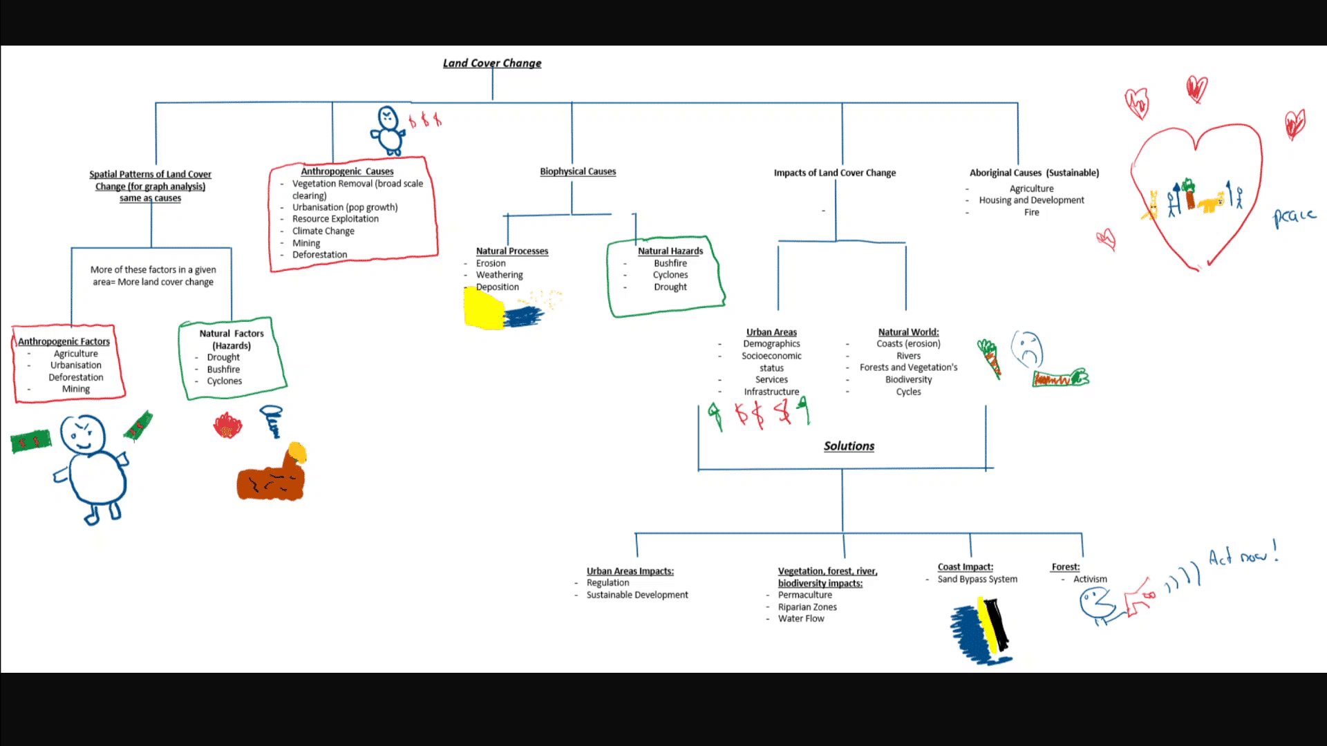
Regarding the work submitted by a student above, answer the questions below.
Which of these patterns are present? Select all that apply.
Lower-order inquiry
Insufficient chunking
Segmental mapping
No backbone
Ans: Insufficient chunking

Question 4

Regarding the work submitted by a student above, answer the questions below.
Question 4.1
Insufficient chunking is:
Too many relationships come in and out of one chunk
The chunks that have been formed are of a low quality
Not enough relationships coming in and out one chunk
There is not enough information on the map to perform proper chunking
Ans: Too many relationships come in and out of one chunk

Question 4.2
Insufficient chunking occurs because:
Learners do not focus on comparing, finding similarities, and identifying relationships.
The information is too complex to group more extensively.
Similarities and relationships between concepts and ideas have not been explored adequately.
Some information cannot be grouped any differently due to the nature of the information.
Ans: Similarities and relationships between concepts and ideas have not been explored adequately
Learning notes
Beginner Level Prestudy - Basic Organisation
Insufficient chunking is one of the most common mistakes of a beginner. This often happens because after the most obvious groups have been created, there is no further exploration of how the information could be divided into further sub-groups. Remember that even within a group, information might be similar and related. Moreover, multiple groups can sometimes be combined into a larger parent group. The simpler and more discretely we can group and connect information, the better our retention and depth of expertise.
The other pattern that is worrying but not definite is hieroglyphics. This is because the visualisations that are used are discrete, isolated and directly replace words at a 1-to-1 ratio. The visuals are also not very abstract and are likely to be easily forgettable. A common additional problem that is not seen here is that learners can often then reuse the same images for whenever they encounter the same word, often on the same map. This is not obvious in this example.

Question 5
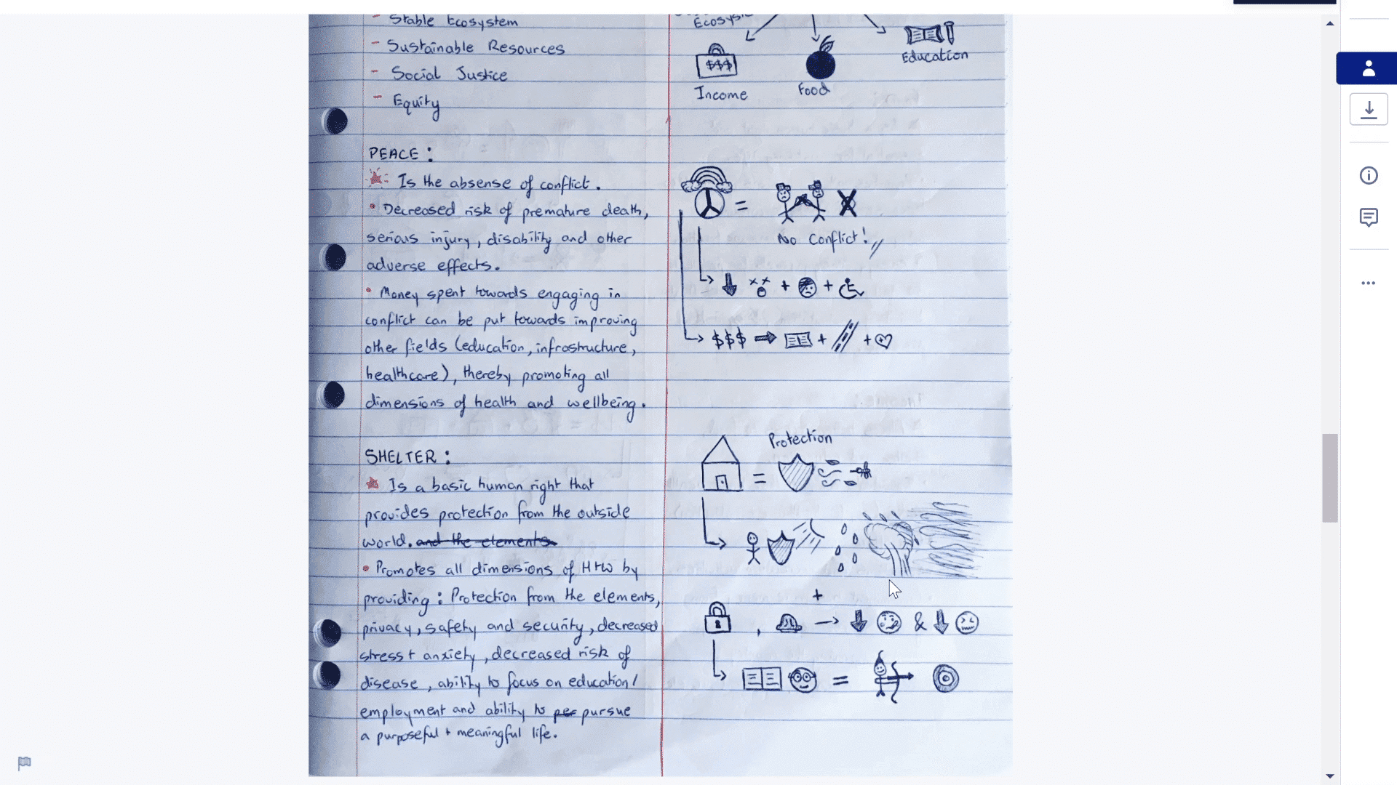
Regarding the work submitted by a student above, answer the questions below.
Which of these patterns are present? Select all that apply.
Over-visualised
Hieroglyphics
Waterfall
Lines Over Arrows
Detail Stripped
Ans: Over-visualised
Hieroglyphics

Question 6

Regarding the work submitted by a student above, answer the questions below.
Question 6.1
Hieroglyphics is:
When your notes are so messy and hard to read that it's like trying to decipher hieroglyphics.
When there are so many images that the notes are hard to follow.
When words are directly replaced with simple images at a 1-to-1 ratio, and then used repeatedly and sometimes linearly.
When images are too small to be memorable or serve as landmarks in our notes.
Ans: When words are directly replaced with simple images at a 1-to-1 ratio, and then used repeatedly and sometimes linearly.

Question 6.2
Hieroglyphics can occur because (select all that apply):
Learners have misunderstood why visualisations can improve memory.
Learners have lots of content to make notes for and turn into visuals.
Learners are in a rush due to time pressures.
The content is very image-heavy inherently and there are many diagrams that must be included in the notes.
Ans: Learners have misunderstood why visualisations can improve memory.
Learning notes
Why We Process Notes
Hieroglyphics is the repeated use of simple images to directly replace words. This usually occurs because learners have misunderstood why visualisations can be effective. Using images can reduce word-count, force deeper processing of information, and create memory cues through the use of visual ‘landmarks’ in the notes. When images are used like hieroglyphics, it is not substantially more memorable than simply using words. Ultimately, our brain has to memorise the images and where they were to make sense of the knowledge, just like how it would have to with words. In the example, you can see the notes are ultimately still very linear and there are minimal relationships and networks between concepts.

